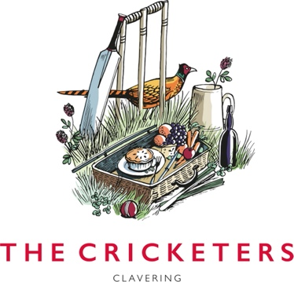

Wood fired Pizza
Garlic bread –10 Cheesy garlic bread – 12

Margherita 13.50 VGA
Marinara - tomato base, garlic, basil VGA 13.50
Pepperoni 14
Pulled maple glazed beef brisket, mozzarella 16.5
Sun blushed tomato, artichokes, red onion, mozzarella 15 VGA
‘Annie’ – Mozzarella, prosciutto, brie, black pepper, honey 14
‘Rosa’ - parmesan, red onion, pistachio, rosemary 14 VGA
Fennel sausage, mustard, sage, mozzarella 15
Mushroom, goats’ cheese, pickled shallots, mozzarella, tarragon 14 V
‘Verde&bianca’ – lemon zest, basil , mozzarella, rocket 14 V

Additional toppings – 1.5
Pepperoni | Salami | Goats cheese | Mushrooms |Chilli | Pickled shallot | Peppers | Olives | Sun blushed tomatoes | Artichokes
If you have any dietary requirements, please inform a team member
V Vegetarian GF Gluten free GFA Gluten free available VG Vegan VGA Vegan available DF Dairy free DFA Dairy free available
10% service charge may be added to the bill, removal upon request.

